**LAPORAN HASIL PRATIKUM ALGORITMA PEMOGRAMAN**

***PSEUDOCODE DAN FLOWCHART***



**Oleh:**

**RAFKI AHMAD PAGAMANDA**

**NIM: 2311533016**

**DOSEN PENGAMPU: Dr. Wahyudi, S.T, M. T**

**MATA KULIAH ALGORITMA PEMOGRAMAN**

**JURUSAN INFORMATIKA**

**FAKULTAS TEKNOLOGI INFORMASI**

**UNIVERSITAS ANDALAS**

**TAHUN 2023/2024**

**Flowchart**

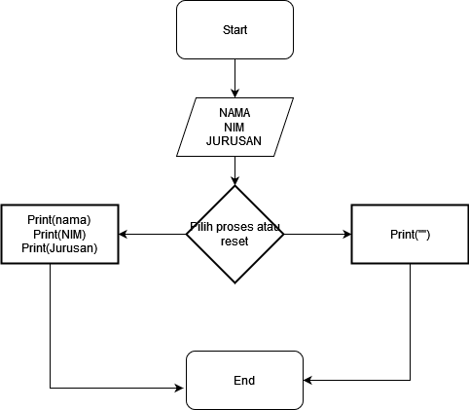

**Pseudocode**

Procedure main():

Initialize JFrame

Set JFrame properties (size, default close operation, layout)

Initialize components (labels, text fields, combo box, buttons)

Add components to the content pane

Set action listener for "Save" button:

Read input from text fields and combo box

Display the input in JLabels

Show a message indicating that the data has been saved

Set action listener for "Reset" button:

Clear the text fields and reset the combo box

Display the JFrame

End Procedure